--- SQL ---

Keys
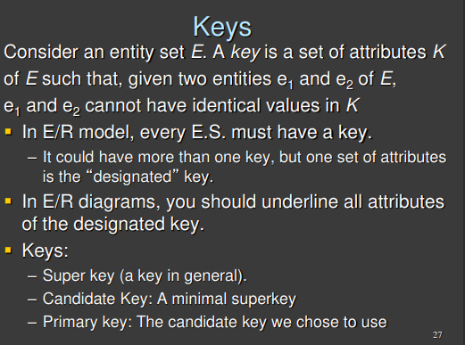

Every entity in the database must be identified in some way or another. We need to be careful in how we choose the key

There can not be two entities in the entity set with the same key.

- superkey/key: there can not be two entities with the same key (like there can not be two entities with the same ssn and surname), but this is not a minimal key, there is an attribute that even if you remove it you will still have a key
- candidate/minimal key: a minimal superkey. If you remove an attribute (like from two you go to one) then it is not able to discriminate between the entities. There might be different combinations
- primary key: the minimal key you decide to use to identify the entity

You need to identity the candidate key, try to find the minimal attributes

Integrity Constraints (ICs)
Condition that must be true for ANY instance of the database. Ensure consistency of data within a database
- Are specified when schema is defined
- Are checked when relations are modified

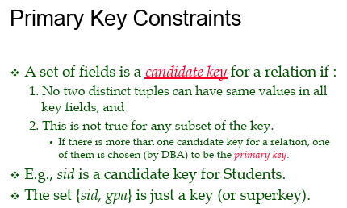

Relational Algebra
- Relational algebra is the assembly language of SQL
- Relational algebra is close ⟹ always sure we will get a table if we perform different operations
- Relation = table

Selection σ
- Selects a subset of rows from relation
- Return new table from another table which contains only the rows that satisfy the condition you want
- Remove duplicates
- Can use any boolean operator ( >, <, ≤, =, ≠, …)
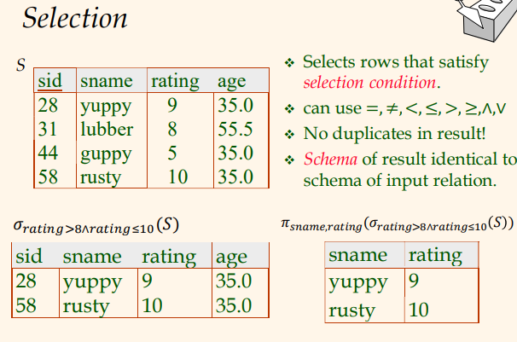

Projection π
- Deletes unwanted columns from relation
- Needs a relation and a list of attributes you want to keep
- The output can NOT contain duplicates

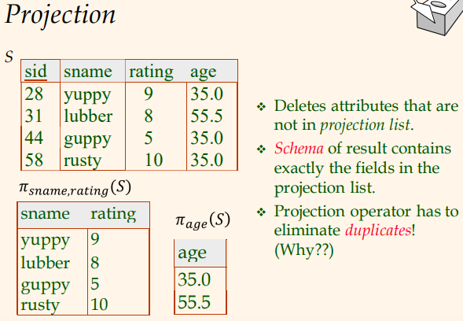

Cross product ✖
- Combine two relations
- Aka cartesian product
- Receive new table that contains every possible combinations of the two tables in input
- If two columns have same name we have a conflict, use parenthesis () use renaming operator
  - Useful to fix the clash and make table more readable

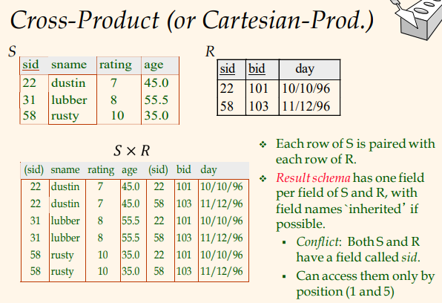
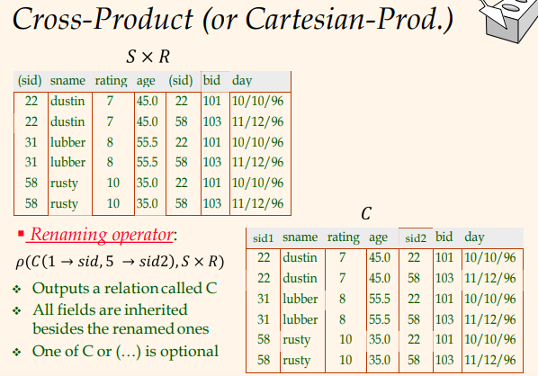

Set-difference ─
- From two input table return the first table without elements that appear in the second table
- Remove from the left all the tuples that appear on the right
- Can not be done in all tables (needs to be union compatible)
  - Same number of fields (number of features)
  - Corresponding fields must have same type (float, integer, …) (same name not mandatory)
- No duplicates in the output
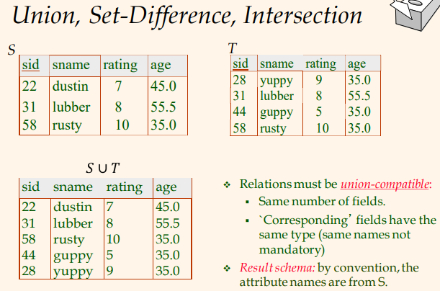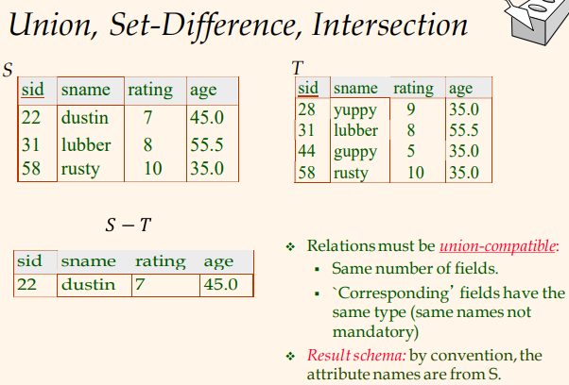

Union U
- Two tables of input and get union
- Can not be done in all tables (needs to be union compatible)
  - Same number of fields (number of features)
  - Corresponding fields must have same type (float, integer, …) (same name not mandatory)
- No duplicates in the output (for union, while for UNION ALL we keep duplicates)



Intersection ∩
- Additional operator ⟹ S ∩ T = S - (S - T)
- Can not be done in all tables (needs to be union compatible)
  - Same number of fields (number of features)
  - Corresponding fields must have same type (float, integer, …) (same name not mandatory)
- No duplicates in the output


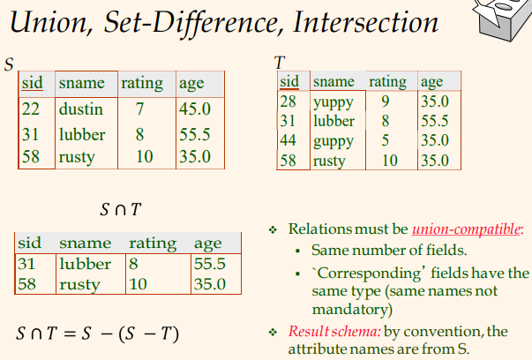

Condition Join ⋈_{c}
- Cartesian product on two table and then apply a selection operator with some conditions

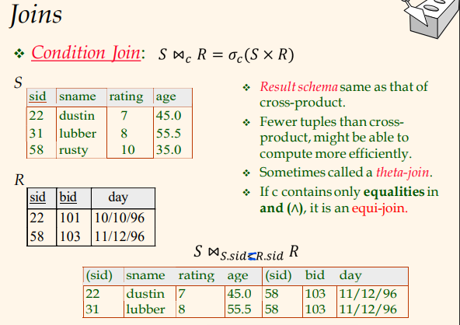


Natural join ⋈
- Cross product but with equi-joint condition. Keep rows that have the same condition element.

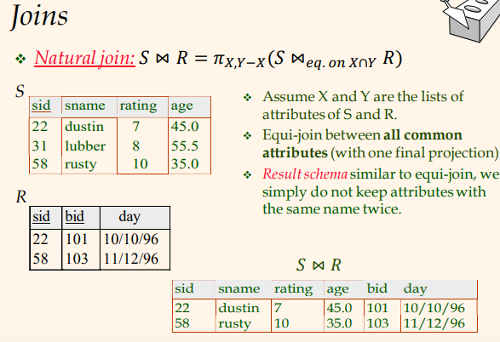



Division ፥
- Needs to be done manually (no operator)
- Can be expressed with basic operators

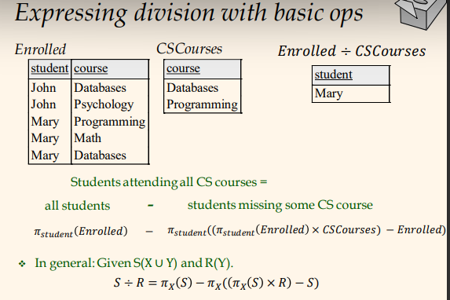

In relational algebra:
- all students: given by lt table, w/ project students name ⟹ get Mary, John only once
- students who miss a course: 2 steps
- take student from S table
- perform cartesian product w/ courses ⟹ get every combo S-CSCourse
SO: we get some real combo - some other fake
- remove from all combo the real ones=left only fake ones
- keep only name w/ selection student
- From all S remove the ones that miss some course=get S who attend all c

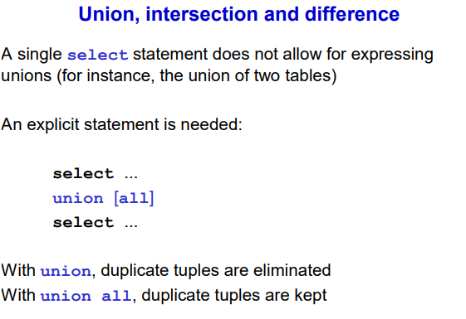
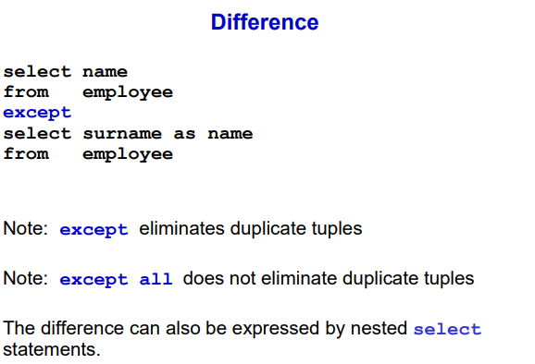
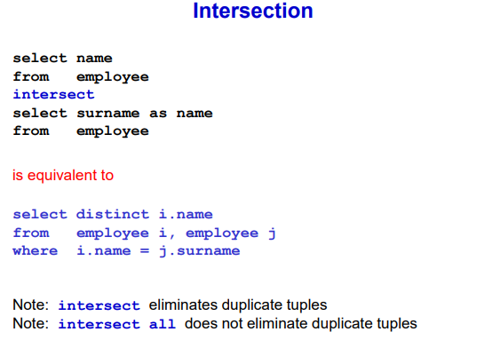

Queries and NULL

Arithmetic operations
- Arithmetic operations with NULL return NULL. Whenever you combine a NULL value with arithmetic operation you get NULL
- Boolean aggregators (SUM, AVG, MIN, MAX) ignore NULL values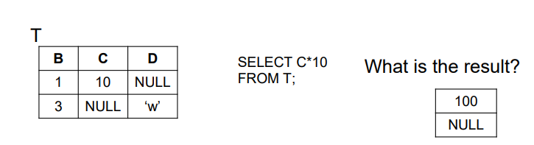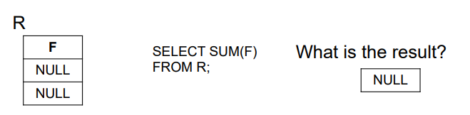

Count

- Count(*) count the tuples regardless of their content, no matter the value
- Count(F) count all values of F that are not NULL (including duplicates), count how many non null values
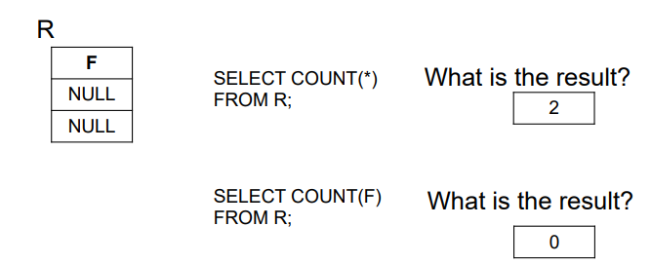

Group by

- Group by not ignore NULL values
- Group all NULLs in a separate group
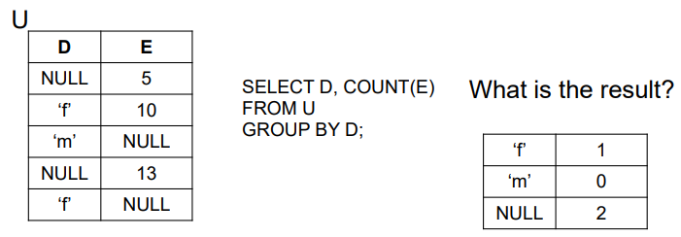
(m is associated to 0 because COUNT always return a number)

Joint condition
- We can not compare 10 with NULL since we do not have a value NULL and so the row is not returned
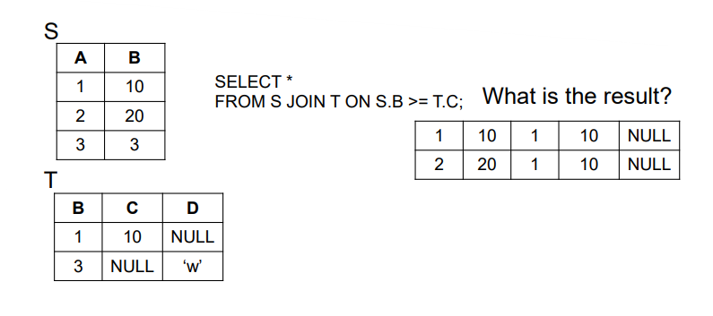

COALESCE()
A function that returns the first non-null value in a list.

SELECT COALESCE(NULL, NULL, NULL, 'W3Schools.com', NULL, 'Example.com'); it will return W3Schools.com

--- Data Warehouse ---

Data warehouse: more useful to do analytics by using extract, transform, load to move from database to data warehouse

- OLAP (On-Line Analytical Processing): operations like aggregation to analyze portions of a database, query data. Query are dynamic, multidimensional and scan huge amount of records to process a set of numeric data
- OLTP (On-Line Transactional Processing): operations that modify, delete, insert and query data. query to read/write a small number of tuples from tables connected by simple relations.

Data warehousing characteristics
- Accessibility to user not very familiar with IT and data structures
- Integration of data on the basis of a standard enterprise model (different individual database to have a common schema)
- Query flexibility to maximize the advantages obtained from the existing information. Let user to see data in a simpler way
- Multidimensional representation giving users an intuitive and manageable view of information
- Correctness and completeness of integrated data. Don’t want inconsistency, clean the data to be consistent with all the sources

Data warehouse have the following features:
- Subject oriented: focus on what matters to the decision maker
- Integrated and consistent: provide a reconciled unified view of all the data
- Show its evolution over time: time is part of the keys, keep track of history
- Non volatile: data is never deleted

Single-Layer architecture
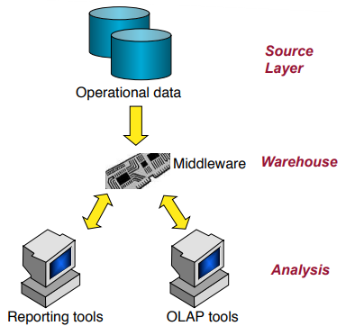

- Goal: minimize the amount of data stored
- Data warehouse is virtual
- Aims to minimize the amount of data stored by having only a single, physical layer (aka the source layer). This means that the data warehouse is essentially virtual.
- Fails to meet separation between OLTP and OLAP ⟹ same system is used for everyday transactions and for complex queries and analysis, which can slow down the performance

Example: Imagine a small business that uses a single database to manage sales (transactions) and also to generate monthly sales reports (analysis). The same system is doing both jobs, which might be fine for a small scale but would be problematic for a larger company.

Two layer architecture
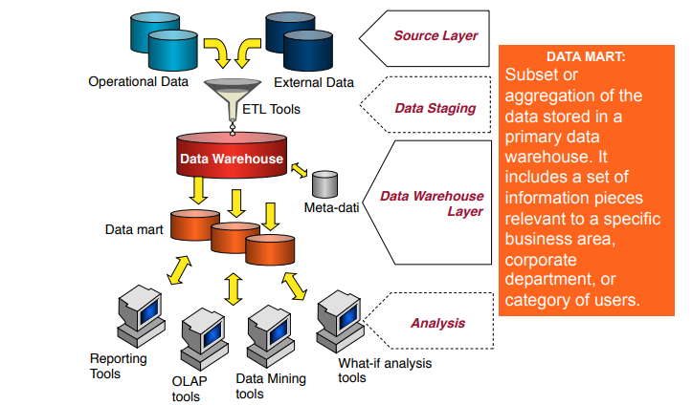

- Data marts: These are subsets of the data warehouse tailored to the specific needs of different departments or business units.
- ETL Tools: These are used for Extracting, Transforming, and Loading data from the operational layer to the data warehouse.

Example: Consider a medium-sized retailer that uses one system to process sales at the checkout (OLTP) and a separate data warehouse to analyze purchasing trends and inventory (OLAP). The data warehouse pulls data from the transaction system using ETL tools, and different departments have their own data marts with relevant information.

Three layer architecture

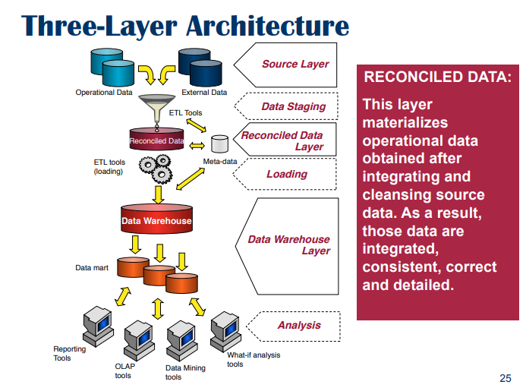

- Reconciled Data Layer: This is where data from various sources is combined and cleaned before being moved to the data warehouse. It ensures that the data in the warehouse is consistent and reliable.
- Separation of concerns: This structure more clearly separates the processes of data extraction and integration from the management of the data warehouse.
- Potential redundancy: While offering many benefits, this approach can lead to the duplication of data, which might be a concern for some businesses.

Example: A large multinational corporation might have multiple operational systems for different regions and departments. Data from all these systems are extracted, cleaned, and reconciled before being loaded into a central data warehouse. This warehouse then feeds various data marts tailored to the needs of individual regions and departments, allowing for complex analysis without impacting the performance of the operational systems.

ETL (Extract, Transform and Loading)
Goal: extract, integrate and clean data from operation sources to eventually feed the data warehouse. Producea single high quality detailed data source

Consist in three phases:
- Extraction: collect data from sources
- (Cleaning): solve errors (fix missing values, …)
- Transformation: adjust the format of data from source schemata to reconciled schemata
- Loading: entering data into the data warehouse and uploading already existing data

OLAP
- Allow to see “the cube” in different ways.
- Can write different queries and can be used by non experts

Roll-up
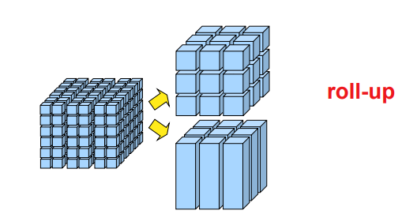

- Increase in data aggregation, removes a detail level from a attribute hierarchy
- Aggregate on a certain dimension
- From more granular to less granular

Drill-down
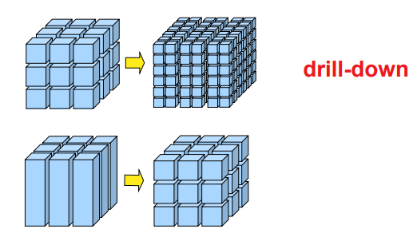

- Inverse of roll-up
- Reduce the level of aggregation in the data
- From less granular to more granular

Slice-and-dice
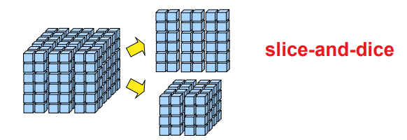

- Produce subcubes starting from cubes
- Slicing: reduce the number of cube dimensions after setting one of the dimension to a specific value ⟹ choose a specific value
- Dicing: reduce the set of data being analyzed by a selection criterion ⟹ pick an interval and extract a smaller cube from a bigger cube

Pivoting
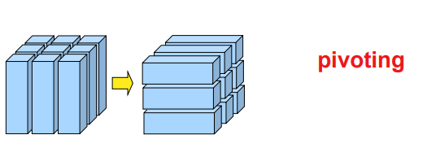

- Change the structure of the cube, when a different view of data in the cube is needed
- Useful to reorganize the sata

Measure aggregation
- A measure is additive wrt a given dimension if the SUM operator is freely applicable to that measure along that dimension, otherwise is non-additive.
- Is additive if the sum operator makes sense.
- As an example, the quantity sold is an additive measure wrt time. If I fix all other dimensions and I vary time I can sum up the pieces sold for a larger time. Also sold is additive with city
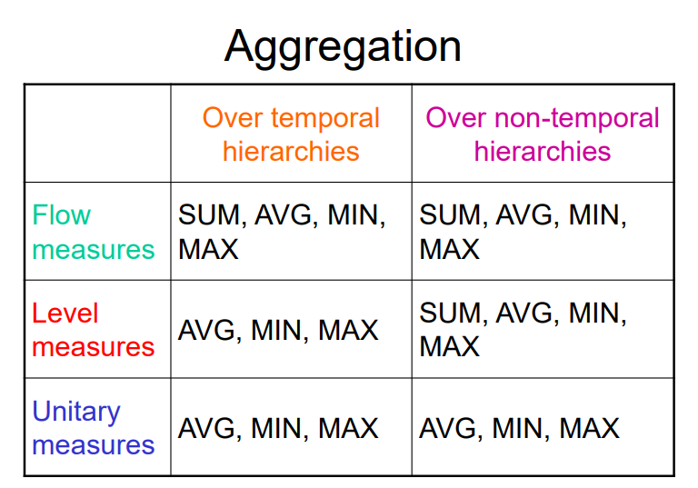

Flow
- Related to time period
- Additive on BOTH time and non-time dimensions
- N. of items sold in a day
- Monthly gross income

Level
- Make sense only in a particular time instant. Need a precise time instant to tell you the value
- Non additive over time dimension, but additive on other dimensions
- Products in store, in an interval does not make sense, but on a precise moment it has sense
- number of people that live in a city, at a certain time it make sense, but on a period it does not (I can tell the average)

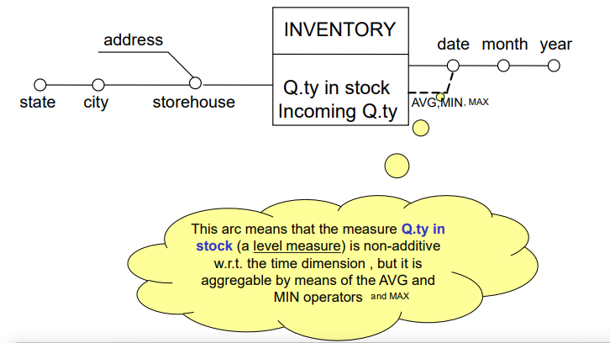
(If I do not specifying anything it means every operator can be used)

Unitary
- Relative measures
- Non additive on all dimensions
- Unitary price at a given instant
- Money change rate, interest rate

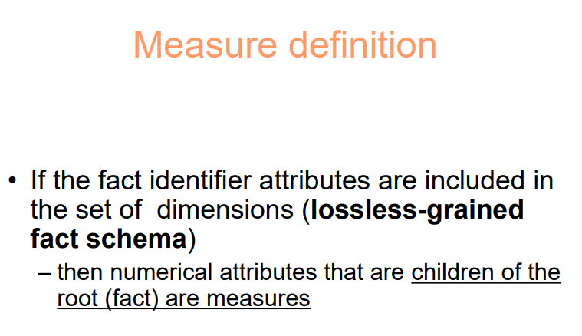
DIMENSION DEFINITION
Convert desired tree obtained into a fact schema(dim-measures-name of fact)
Dim: some direct children of root (eg. sale: product-date-shop)
WARN: time should always be a dim (if we don’t have it, we add it manually)

Measures:
Lossless-grained fact schema: identifier att of root are in desired tree=included in set of dim
- measures=numerical att that are children of root
Lossy-grained fact schema: measures are def by applying aggregate op to root numerical att
- generally: sum/avg/min/max/count
- if no att directly connected root perceived as measures, but other far away yes, do grafting iteratively until we get wanted att

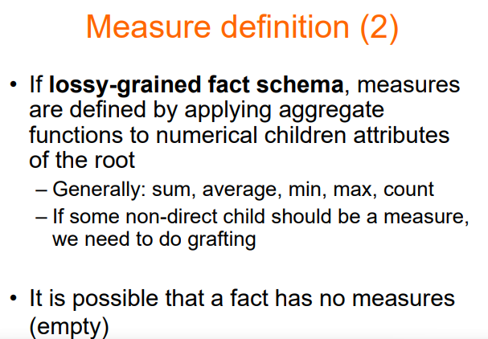

Glossary: how to compute the measures, an expression associated with each measure that describes how we calculate the measures using the attributes of the source schema that identify the measure
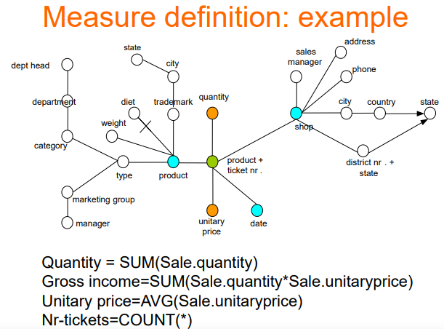

Cyclic relationships
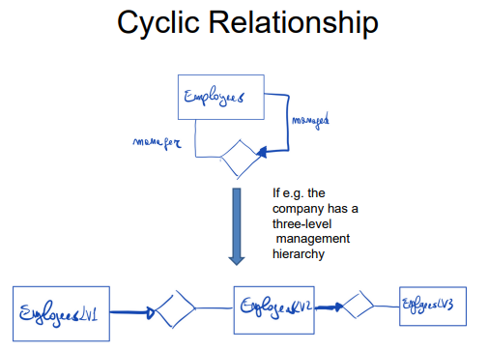

- Must be broken after a certain number of iterations
- You represent only a part of the loop.
- It is not really a cycle, is up to you decide where to stop

Data Warehouse Logical Design

ROLAP
- Relational OLAP (On-Line Analytical Processing)
- Start from fact schema (the data warehouse project) and try to fit the data in a standard relational database
- Describes all techniques-methodologies to do analytics on data
- Disadvantage: relational models do not consider dimensions, measures, hierarchies, facts, … ⟹ solution: star schema
- ROLAP can store only useful cells (aka occurred events)

Star schema
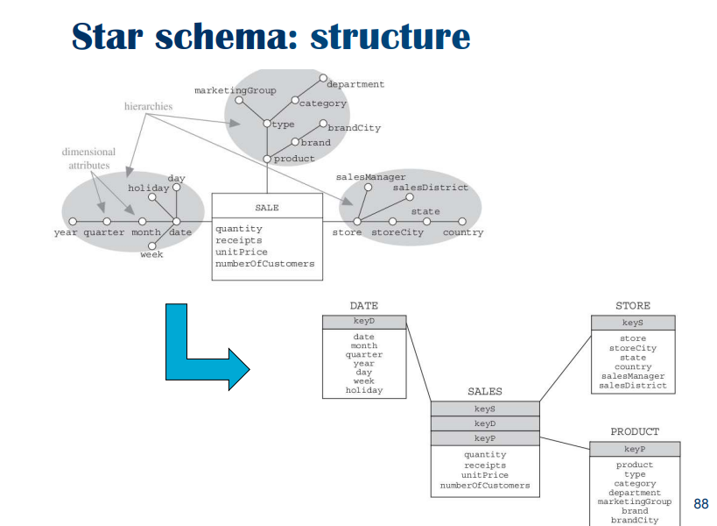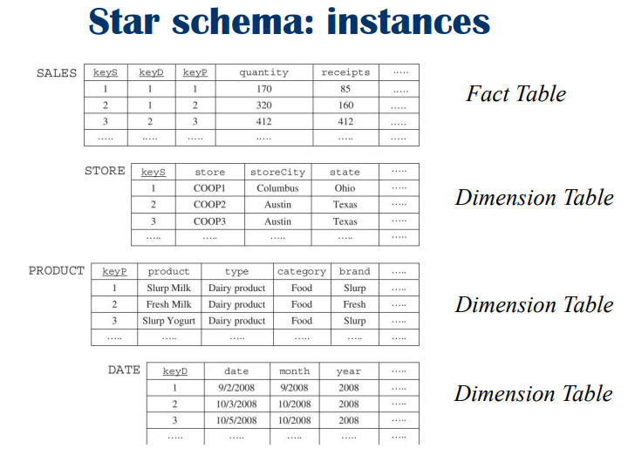

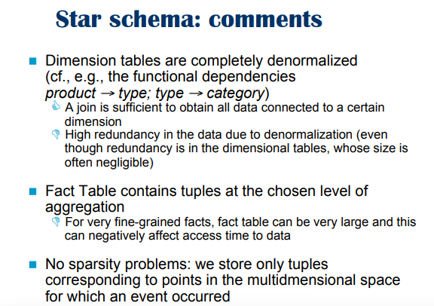

MOLAP
- Multidimensional OLAP (On-Line Analytical Processing)
- Advantage:
  - Multidimensionals operations can be simply and naturally realized without need of resorting to joins
- Disadvantage:
  - No standard query language
- Complex techniques to minimize the space required to keep track of not occurred events

Data cube:
- Primary cube surrounded by a collection of secondary cubes
- Secondary cubes do not need to be physically available because you can calculate them by aggregating their primary cube along a dimension
- You might still need to store some secondary cubes to improve the query response time
- Data cubes are stored in arrays, each array element is associated with a set of coordinates on a value space
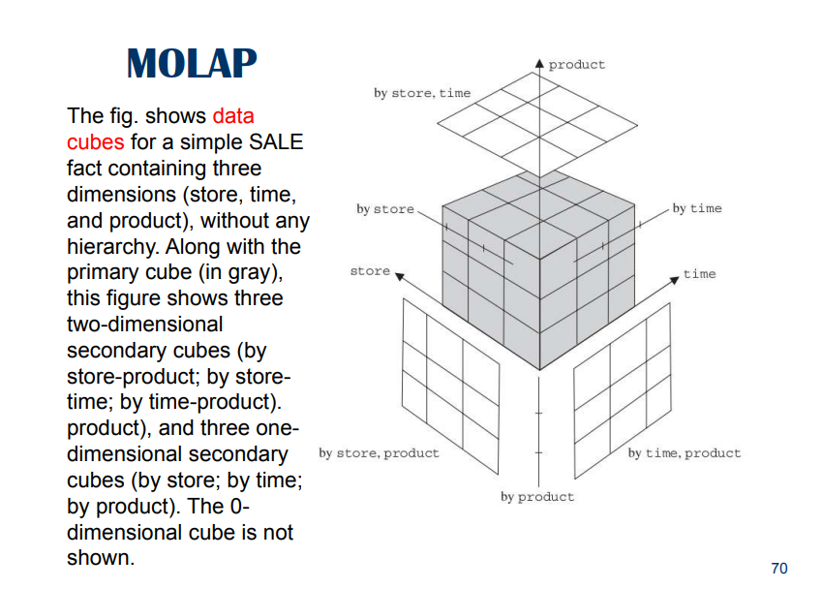

Problem of sparsity
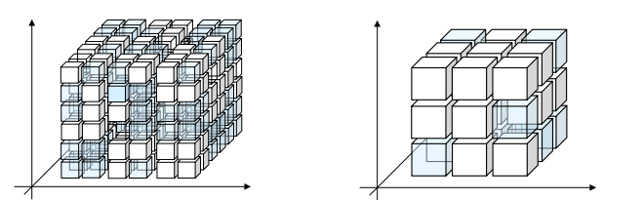

- Pick the cube and try to group it in chunks and classify it as dense or sparse
- Store the dense part of the cube, while the spare are not actually stores

⟹ Hybrid OLAP (different techniques)
- Dense chunks stored in MOLAP and sparse chunks in ROLAP
- Primary cubes in ROLAP and secondary cubes in MOLAP (aggregation reduces sparsity)
- Frequently access data in MOLAP and remaining in ROLAP

VIEWS

- Primary Views: These are views that correspond to primary aggregation patterns, essentially representing non-aggregated data. They reflect the most detailed level of data, closely aligned with the raw data in the fact tables.
- Secondary Views: These views correspond to secondary aggregation patterns, which involve aggregated forms of data. They are useful for simplifying and speeding up data queries by pre-aggregating data according to specific patterns.

DESCRIPTIVE ATT
Descriptive att(add descriptive info to an attribute), eg. custom w/ name-surname
To convert them into logical schema:
- when connected to dim att, put them in the dim table of this dim att
- when connected to fact schema (eg. ticketsID for tickets), put them in fact table

This has sense when we keep lv of granularity described by the fact schema
- att connected to fact schema disappear in secondary views (since desc att w/ 1-to-1 correspondence w/ its att)

Placement of Descriptive Information:
- Connected to a Dimensional Attribute: If this non-aggregative information is related to a dimensional attribute (for example, the color or brand of a product in a sales database), it should be included in the same dimension table as the attribute it describes.
- Connected Directly to the Fact: If the information is directly related to the fact table (for example, a comment or description specific to each transaction or event), it should be included in the fact table itself.

Frequent Itemsets Mining and Association Rule Mining

- Analyze data to understand customer behavior
- Goal: discover patterns and associations

- I: set of items sold in a retail store I = {pasta, lemon, bread, …}
  - There are $2^{I}-1$ possible subsets
- D: transaction dataset, set of transactions
  - Each transaction has a unique identifier (Transaction ID), the transaction ID of T₄ is 4
  - Each transaction have a size k of items
- A transaction is a set of items

Support: frequency of an itemset X

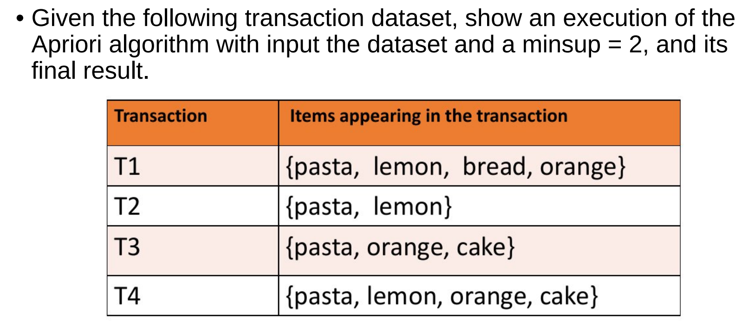

Step 1: start with k = 1 and compute their support
{pasta} sup4
{lemon} sup3
{bread} sup1
{orange} sup3
{cake} sup2

Then remove bread since sup{bread} since it is smaller than 2

Then do all the combinations with k = 2 but without bread and compute their sup
{pasta, lemon} sup3
{pasta, orange} sup3
{pasta, cake} sup2
{lemon, orange} sup2
{lemon, cake} sup1
{orange, cake} sup2

Remove {lemon,cake} and do all combinations with k =3 and compute the sup
{pasta, lemon, orange} sup2
{pasta, orange, cake} sup2

No removing
{pasta, lemon, orange, cake} has sup1 so remove it

